1. Fluocell can be downloaded from the Github site: <https://github.com/lu6007/fluocell>
2. To make *Fluocell* accessible to multiple users:   
   first, copy the ‘fluocell/’ folder to your Program Files.
3. Go to fluocell > src > gui > java
   1. Create a shortcut from **fluocellJava.jar.** This can be placed on your desktop, etc.
   2. Go to Program Files > MATLAB > 2015b > toolbox > local  
      (Location may differ based on your MATLAB installation.)
      1. Find and then copy **pathdef.m** to the fluocell>…>java folder from before
4. In the fluocell>…>java folder, modify the **default.property** and the **pathdef.m** files by changing the security settings by allowing ALL APPLICATION PACKAGES and “Users” to have permissions for Full Control:  
   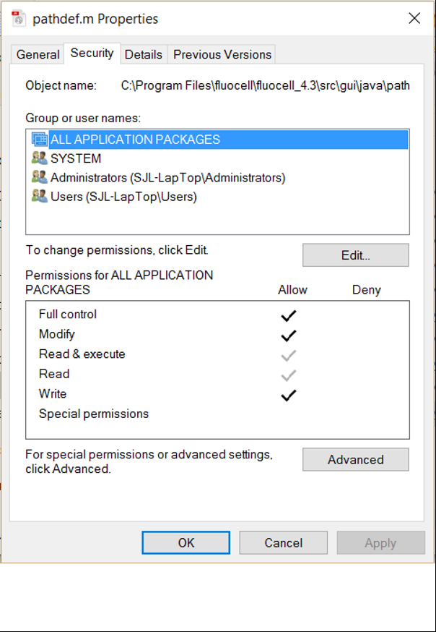
5. Next, modify the **default.property** in the fluocell>…>java folder so that it asks for MATLAB “2015b” instead of the 2014b edition (or for whichever edition of MATLAB is installed).  
   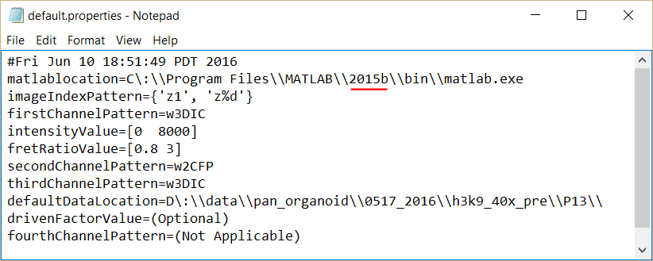
6. In addition, the data folder need to be copied to a local folder for each user to allow reading and writing to the metadata. Alternatively, the setting of the data folders can to be changed to give all users access.

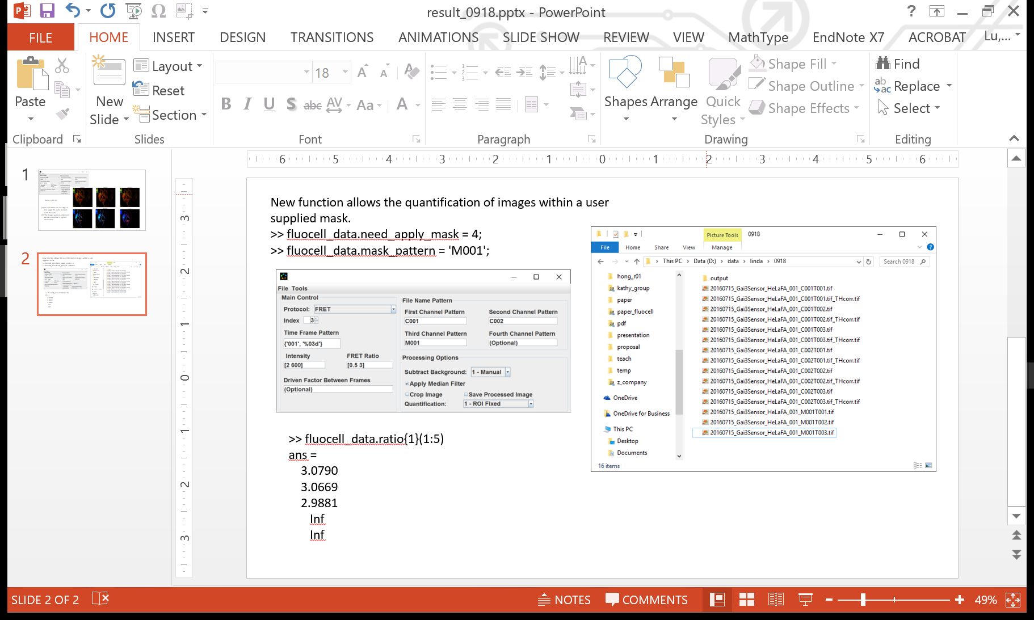**New and tentative functions**

***Using Watershed for Cell Separation***

1. First, enable *Fluocell* to display and quantify multiple cell regions:  
   >>fluocell_data.multiple_object = 1;  
   Output should look something like this:  
   
2. To use a simple (faster) watershed cell separation method, enter the following:  
   >>fluocell_data.segment_method = 1;  
   or, for a more involved watershed cell separation method, enter the following:  
   >>fluocell_data.segment_method = 2;

Blow shows the outputs for methods 1 and 2.



Method 2

Method 1

Note: For the current version of *Fluocell*, the segment_method parameter only enables *Fluocell* to create a visual separation of cells. Any quantitative analysis would not incorporate how the cells are segmented using the watershed method.

**Data Structures**

When the quantification setting in *Fluocell* is enabled, some new fields are added to the data structure, fluocell_data. Some of the frequently used fields include:

(Example shows fluocell_data right after initialization)

fluocell_data =

time: [200x2 double]

ratio: {[200x1 double]}

channel1: {[200x1 double]}

channel2: {[200x1 double]}

channel1_bg: [200x1 double]

channel2_bg: [200x1 double]

All values are stored in column vectors.

Each row is a different time frame.

fluocell_data.time(:,j)

.time(:,1) - the index

.time(:,2) - the time

fluocell_data.ratio{i}(:,j) - ratio intensity

i - object

j - region(s) of interest (ROI)

Each object is its own cell and can have one or more ROIs.

fluocell_data.channel1{i}(:,j) - intensity value of channel 1

i - object

j - region(s) of interest (ROI)

Each object is its own cell and can have one or more ROIs.

fluocell_data.channel2{i}(:,j) - intensity value of channel 2

i - object

j - region(s) of interest (ROI)

Each object is its own cell and can have one or more ROIs.

fluocell_data.channel1_bg(:) - intensity value of the background for channel 1

fluocell_data.channel2_bg(:) - intensity value of the background for channel 2